Bo Lin

**ECE 479/579 Digital Control Systems**

Homework Assignment #6

5.7 A triangle hold is a device that has an output, as sketched in Fig.5.22 that connects the samples of an input with straight lines.

(a) Sketch the impulse response of the triangle hold. Notice that it is non-causal.

(b) Compute the transfer function of the hold.

(c) Use MATLAB to plot the frequency response of the triangle hold.

(d) How would the frequency response be changed of the triangle hold is made to the causal by adding a delay of one sample period.

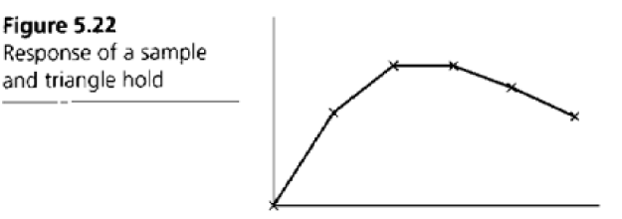

(a)

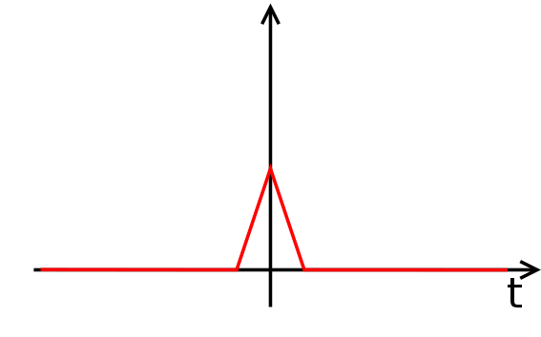

(b)



(c)



Let the x axis as .



(d)Causal first-order hold is the delayed first-order hold.



For this part, I am not sure whether it is delayed first order hold or not. So I read some papers and find out another first-order hold. This one has the right frequency response.

(Transfer function for predictive first-order hold)



Consider a unit step function input



The Laplace transform of unit step is







5.15 Find the transform of the output Y(s) and its samples Y*(s) for the block diagrams shown in Fig.

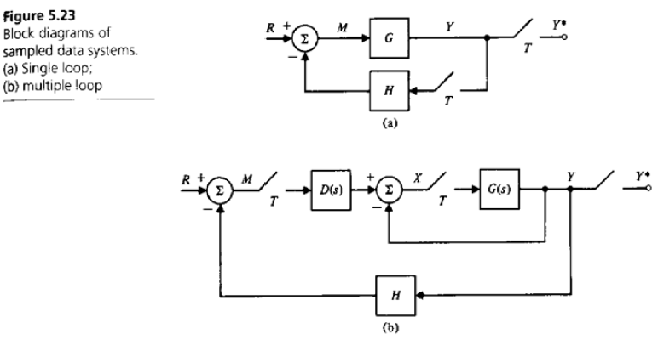

5.23. Indicate whether a transfer function exists in each case.

(a)



For both Y(s) and Y*(s), the M(s) cannot be canceled out, so there does not exist a transfer function.

(b)



For Y(s) the M(s) cannot be canceled, but for Y*(s) there is transfer function exist.

5.16 Assume the following transfer functions are preceded by a sampler and zero-order hold and followed by a sampler. Compute the resulting discrete transfer functions.



